INDIGENOUS DEVELOPMENT ORGANIZATION

**Regd. Society No: 434 of 2019**

**ANNUAL REPORT 2020-21**



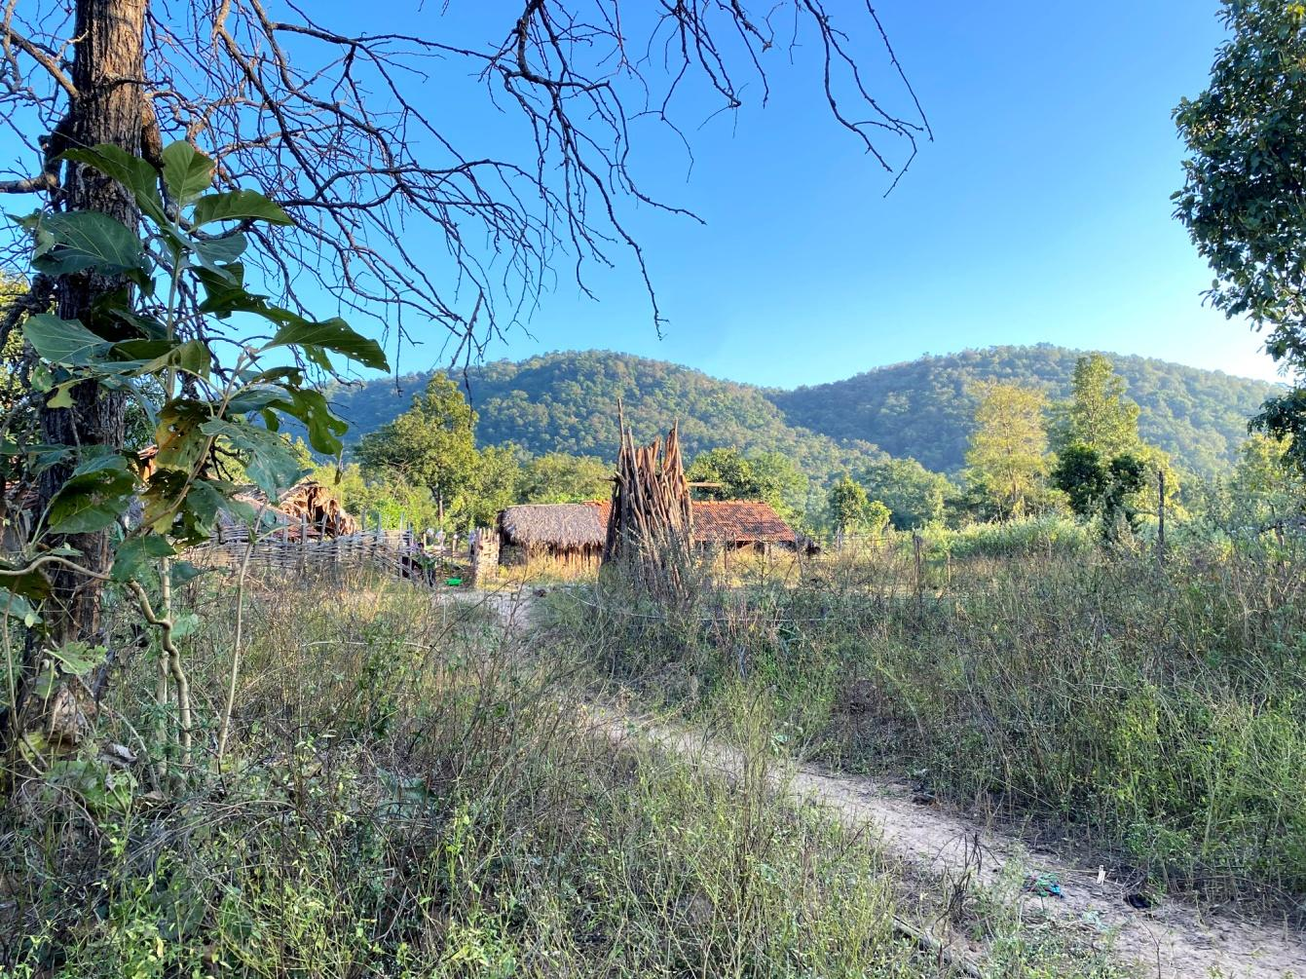



* **ABOUT NGO:** We are working with tribal community in the interior forest habitations (IFHs) & rural villages of the Bhadradri kothagudem district, Telangana. Tribal communities comprise of 37% of overall population in the district. Bhadradri Kothagudem shares it boundaries with Khammam, AP & Chhattisgarh. Majority of tribal communities does not have access to universal healthcare services & due to poor economic status they cannot afford healthcare, nutrition and access to education.

Inspired by philosophy of Sri. APJ Abdul Kalam and humanitarian works of Dr Hanumappa Sudarshan, Dr Prakash Amte and Dr Abhay Bang, Dr Narendar (Founder) in 2016-17 started to visit various regions to understand the needs of communities & finally came across the Bhadradri Kothagudem district in Telangana. After looking at the challenges faced by tribal communities, he decided to work for them & started staying with them since then.

| **LIST OF THE BOARD MEMBERS 2019-2020** | | |
| --- | --- | --- |
| **DESIGNATION** | **NAME** | **BACKGROUND** |
| President | Dr. N. Ravindra Rao | Doctor |
| Vice President | Mogili Vijender | Social Entrepreneur |
| Secretary & Founder | Dr. R. Narendar | Doctor |
| Treasurer | Mahesh Mandava | IT Professional |
| Joint Secretary | K. Mallikarjuna Rao | Private Business |
| Executive Member | B. V. Radhakrishna Murthy | IT Professional |
| Executive Member | Dr. Suresh Reddy | Doctor |

* **OUR MISSION:** We work with marginalized communities – tribal, rural, women and children – bringing health awareness, providing access to healthcare services, nutrition and education, bringing in community empowering models to address those challenges. The model focuses to reduce deaths, diseases, malnutrition & illiteracy.
* Indigenous Development Organisation strives to achieve its objectives through following programs:

1. Health Clinic at Gattumalla village
2. Need based medical camps & awareness programs
3. Monthly Training sessions for Community Health Workers
4. Home-based maternal & newborn care
5. Nutrition program & Nutritional assessments
6. Bridge schools

As interior regions of the district have poor access to healthcare & the tribal community has poor health seeking behaviour, owing to this the maternal and child health indicators are poor in the district. Infant mortality rate is very high. Malnutrition, Anaemia & Malaria prevalence is also very high.

**HEALTH CLINIC:**

* The health clinic was setup at Gattumalla village, Lakshmidevipalli mandal, Bhadradri Kothagudem district with an aim to establish a channel where the patients requiring further diagnosis/ interventions can be brought-in by our trained CHWs and also for over 15000 population around this clinic to reach us conveniently.
* Primary healthcare services (Allopathic & Homeopathic), Antenatal screening, NST & Lab investigations like Spot Haemoglobin, GRBS, RDT malaria tests and RDT dengue tests are done at the clinic.
* Medical camps were done in the interior habitations which had almost no healthcare facility, team of doctors conducting

| Health clinic & Medical camps - Patients visits & services – 2020-21 | |
| --- | --- |
| Total outpatient visits | 4295 |
| Antenatal Checkups done | 102 |
| Patients Referred to Higher centre | 148 |
| No. of surgeries performed at Govt/Private Facilities |  |
| Patients availing Lab investigations | 849 |
| No. of Medical camps conducted | 74 |
| No. of patients reached through medical camps | 2471 |
| No. of patients availing Lab investigations at medical camps | 586 |

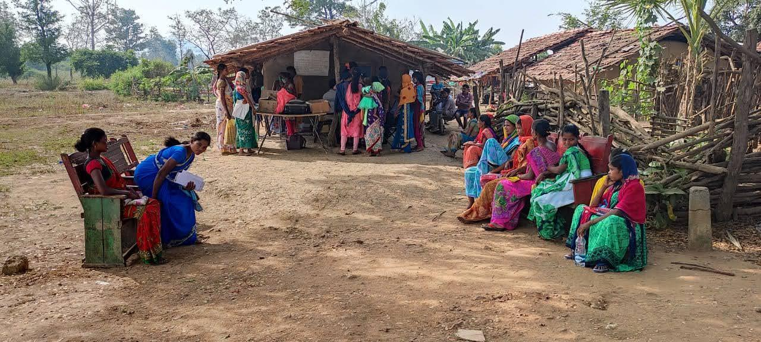

**COMMUNITY HEALTH WORKERS MONTHLY TRAINING:**

To address the challenges in interior habitations, we have identified one community member from each habitation. These individuals have been motivated & regularly trained by our team to provide much needed healthcare services at the door-step (Home Based) to their community members. These individuals are called “Community Health Workers” (CHW).

Each CHW has been provided with a medical kit to provide the health services within the habitation & early identification of high-risk cases which need referral to institutions. The whole idea of this CHW program is to empower the local youth to take charge of their health & also of their community.

Now our trained CHWs can identify high-risk newborns & high-risk pregnancies. They can also do malaria tests and within minutes identify the type of malaria, provide treatment and also refer high-risk cases to higher centre if needed.

| **INTERVENTIONS DONE BY COMMUNITY HEALTH WORKERS WITHIN HABITATIONS** | |
| --- | --- |
| Community health workers trained | 40 |
| Mandals covered | 13 |
| Habitations covered | 42 |
| Population covered | 8000+ |
| No. of Pregnant women - Antenatal checkups | 164 |
| No. of safe deliveries conducted by CHWs | 38 |
| No of Institutional Deliveries |  |
| No of Home Deliveries by TBAs (Vadde) |  |
| Total Tuberculosis patients identified | 9 |
| No of SAM & MAM children referred to NRC |  |
| No of Snake bite cases/Animal attacks referred | 12 |
| No of Carcinoma cases identified & referred | 2 |
| Home based newborn care | 140 |
| Total malaria screening done | 1427 |
| Total malaria cases identified & treated | 579 |
| Patients referred to higher centres | 178 |

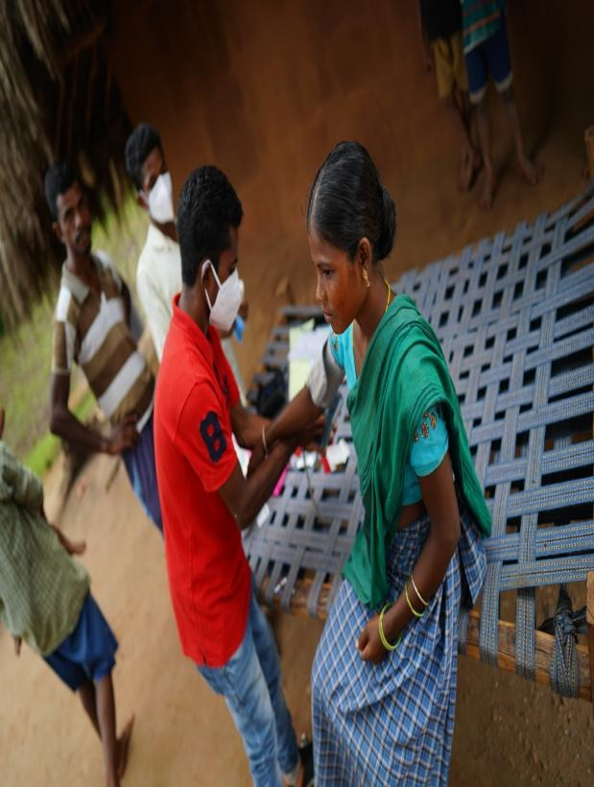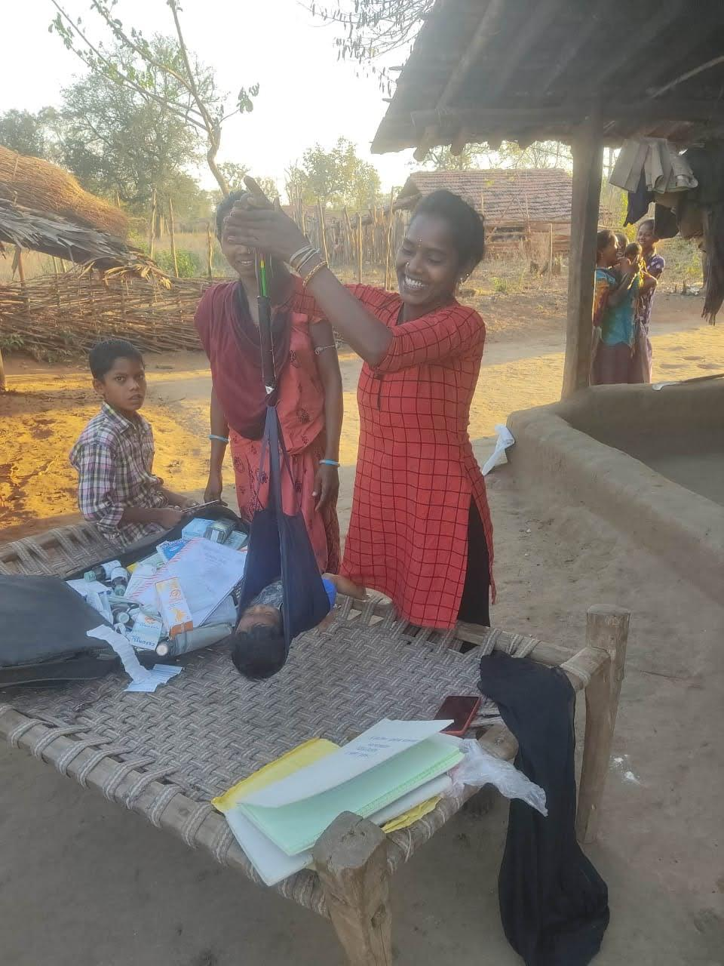

**COVID AWARENESS PROGRAMS:**

Through our community health workers in various habitations we have conducted awareness programs during the COVID PANDAMEIC on following the protocols like social distancing, timely hand washing & isolating symptomatic patients. This was done in a traditional method using the conch, drums by volunteers to ensure everyone in the habitation comes to know about the protocol measures.

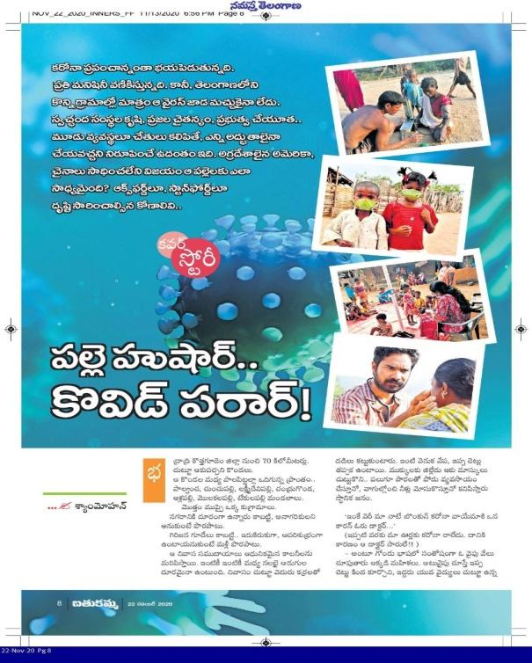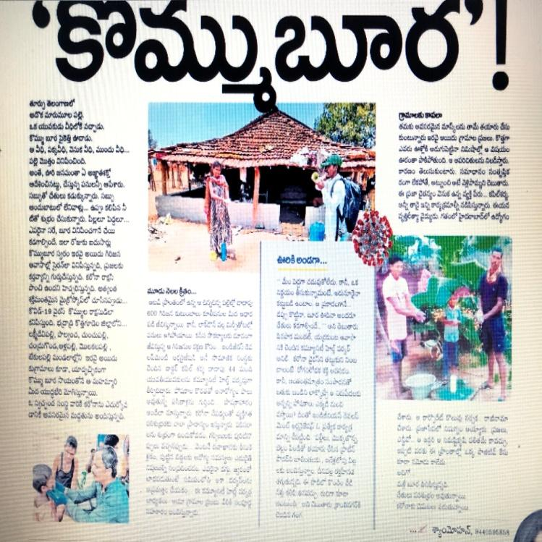

**NUTRITION PROGRAM & ASSESSMENTS:**

Malnutrition & Anaemia prevalence in Under-5 age children and pregnant women is highest in tribal population. According to our study, 70.2% children are underweight & 62.4% of them have wasting. 99% pregnant women and 98% under-5 age children have anaemia.

Our NGO has started providing them our own formulated nutrition powder which has to be consumed every day. To ensure this, spot feeding program has been planned in all the 31 habitations covering over 1000 beneficiaries.

Nutrition Assessment done for ……

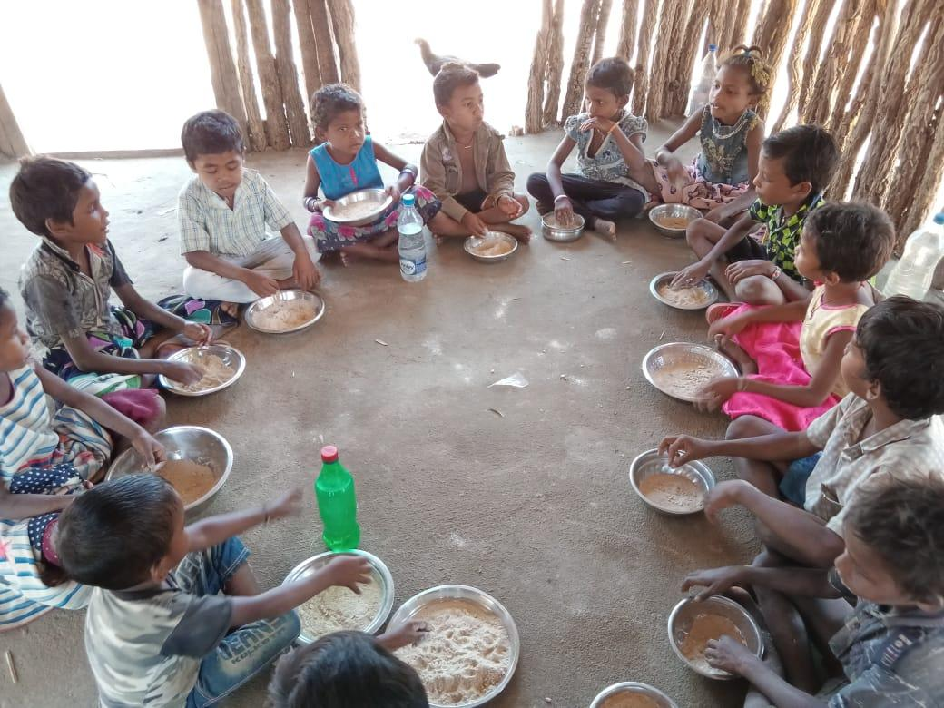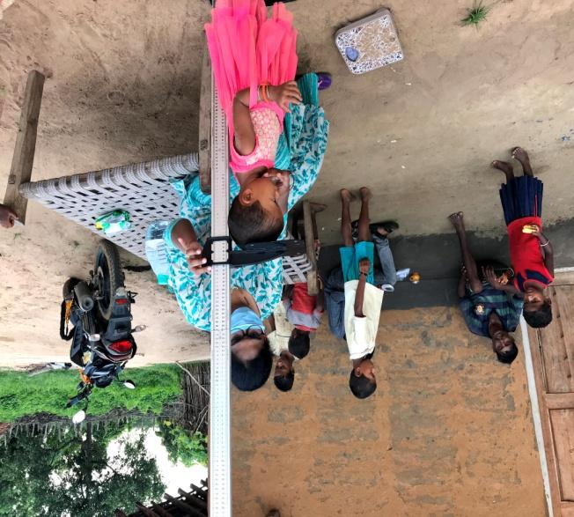

**BRIDGE SCHOOLS:**

In the interior habitations there are no anganwadi centres or schools which made education inaccessible to the tribal habitation children. Sending children directly to mainstream schools also was challenging.

To fill this gap we have established 11 BRIDGE SCHOOLS in 11 habitations itself, where they get basic education & mid-day meal. After identifying potential students we motivate them to join into mainstream schools.

| No. of children in our bridge schools | 350+ |
| --- | --- |
| No. of children joined to residential mainstream schools | 89 |

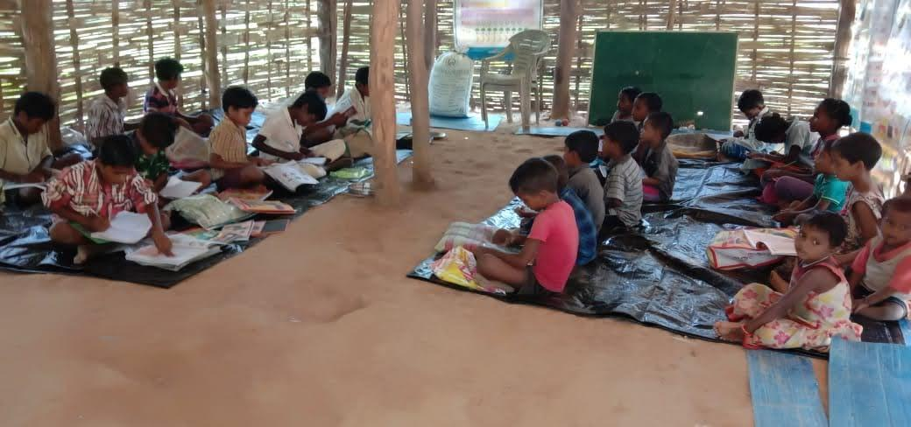

**RECOGNITIONS:** Our team received recognition for the work done in the field of nutrition in the tribal region by the Glenmark Foundation, Representative & Country Director, India, WFP (UNICEF) & various esteemed members at The Nutrition Awards- 2021.

